**Project Name:** **E-mail IDs Validation Project**

**Developer Name: Kapil Davey**

**Project Description:**

Email validation is required in any of the application that looks for email addresses as required information at the registration stage.

There are five ways through which we can perform email validation using a regular expression.

1. Simplest regex to validate email.
2. Adding restriction on user name part.
3. E-mail validation permitted by RFC 5322.
4. Regex to restrict leading, trailing, or consecutive dots in emails
5. Regex to restrict no. of characters in the top-level domain.

**Algorithm:-**

**Step 1**- Start

**Step2** –Create a Scanner class to take input from user

**Step3**-use regular expression to check email is valid or not

**Step4**- use if statement to check the validation

**Step 5**- print result

**Step 6**- stop

**Flow of project:**

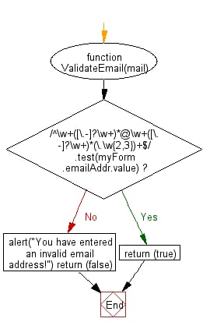

**Conclusion:** This Project is aimed to validate the email ID by using concepts of arrays and control statements

**GitHub Reciprocity Link**:- https://github.com/kapildavey/Phase1.git